

# AUGUST- 2023

**Programme : B.E / B. Tech**

**Course Code : CSA1190**

**Course Name** **: OBJECT ORIENTED ANALYSIS AND DESIGN**

**Date : 30-08-2023**

OOAD PRATICAL DAY 4

**EXP 31 : AGRICULTURE LOAN MANAGEMENT SYSYTEM**

**AIM** : To draw the uml diagram for agriculture loan management system using umbrello.

**USECASE:**

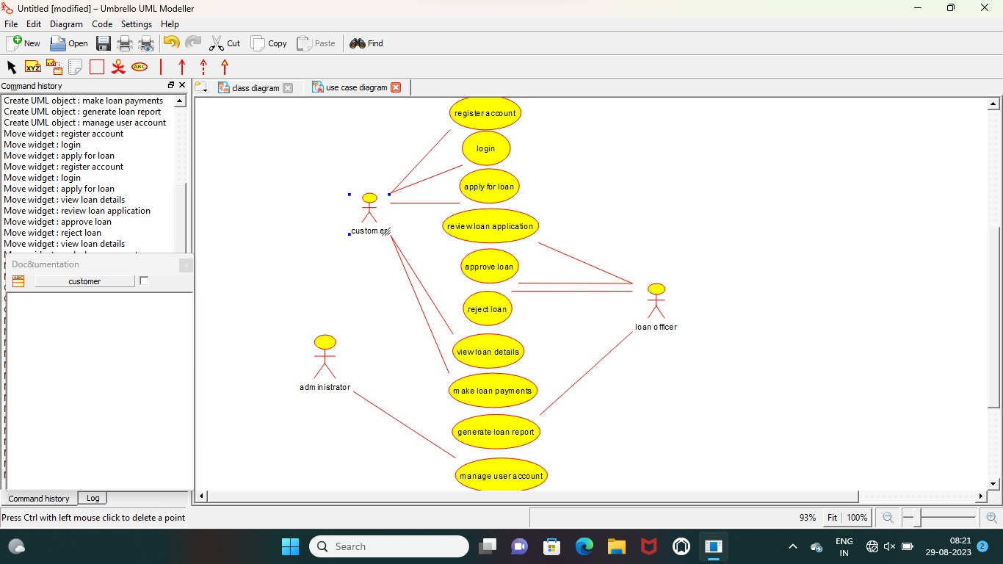

**ACTIVITY :**

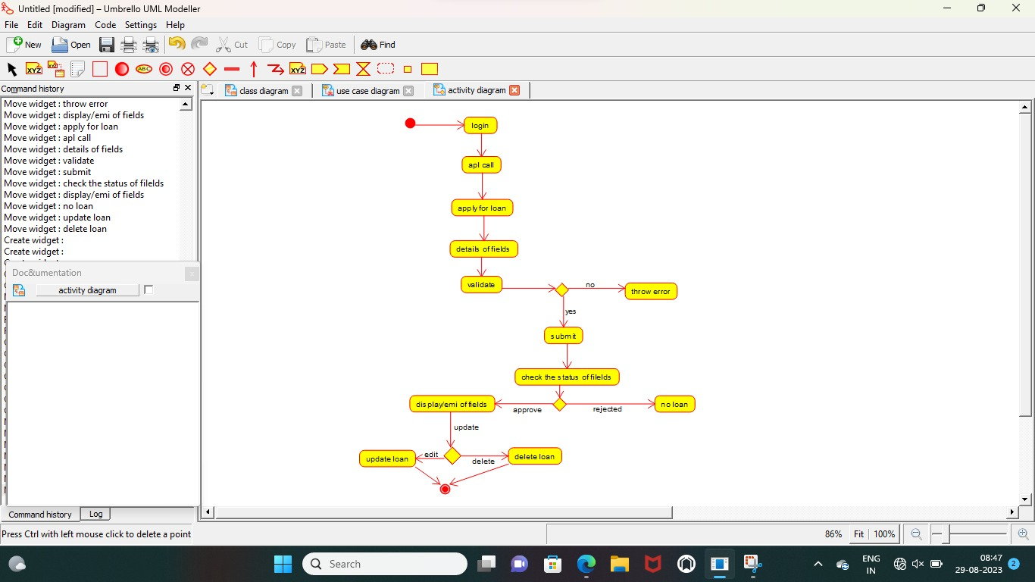

**CLASS :**

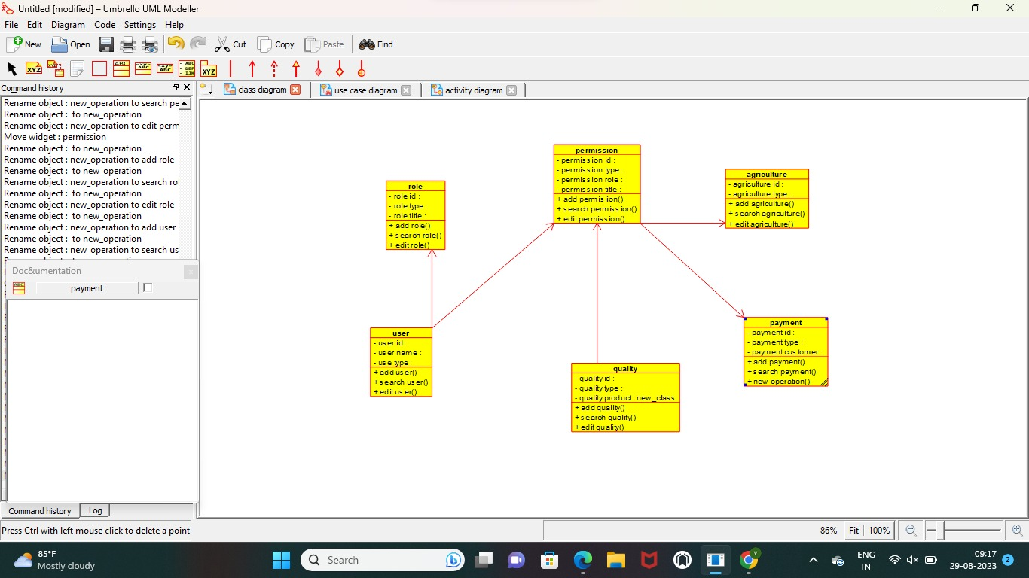

**RESULT** : Program was Executed Successfully using Umbrello**.**

**EXP 32: JEWEL LOAN MANAGMENYT SYSTEM**

**AIM :**  To draw the uml diagram for jewel loan management system using umbrello.

**CLASS DIAGRAM :**

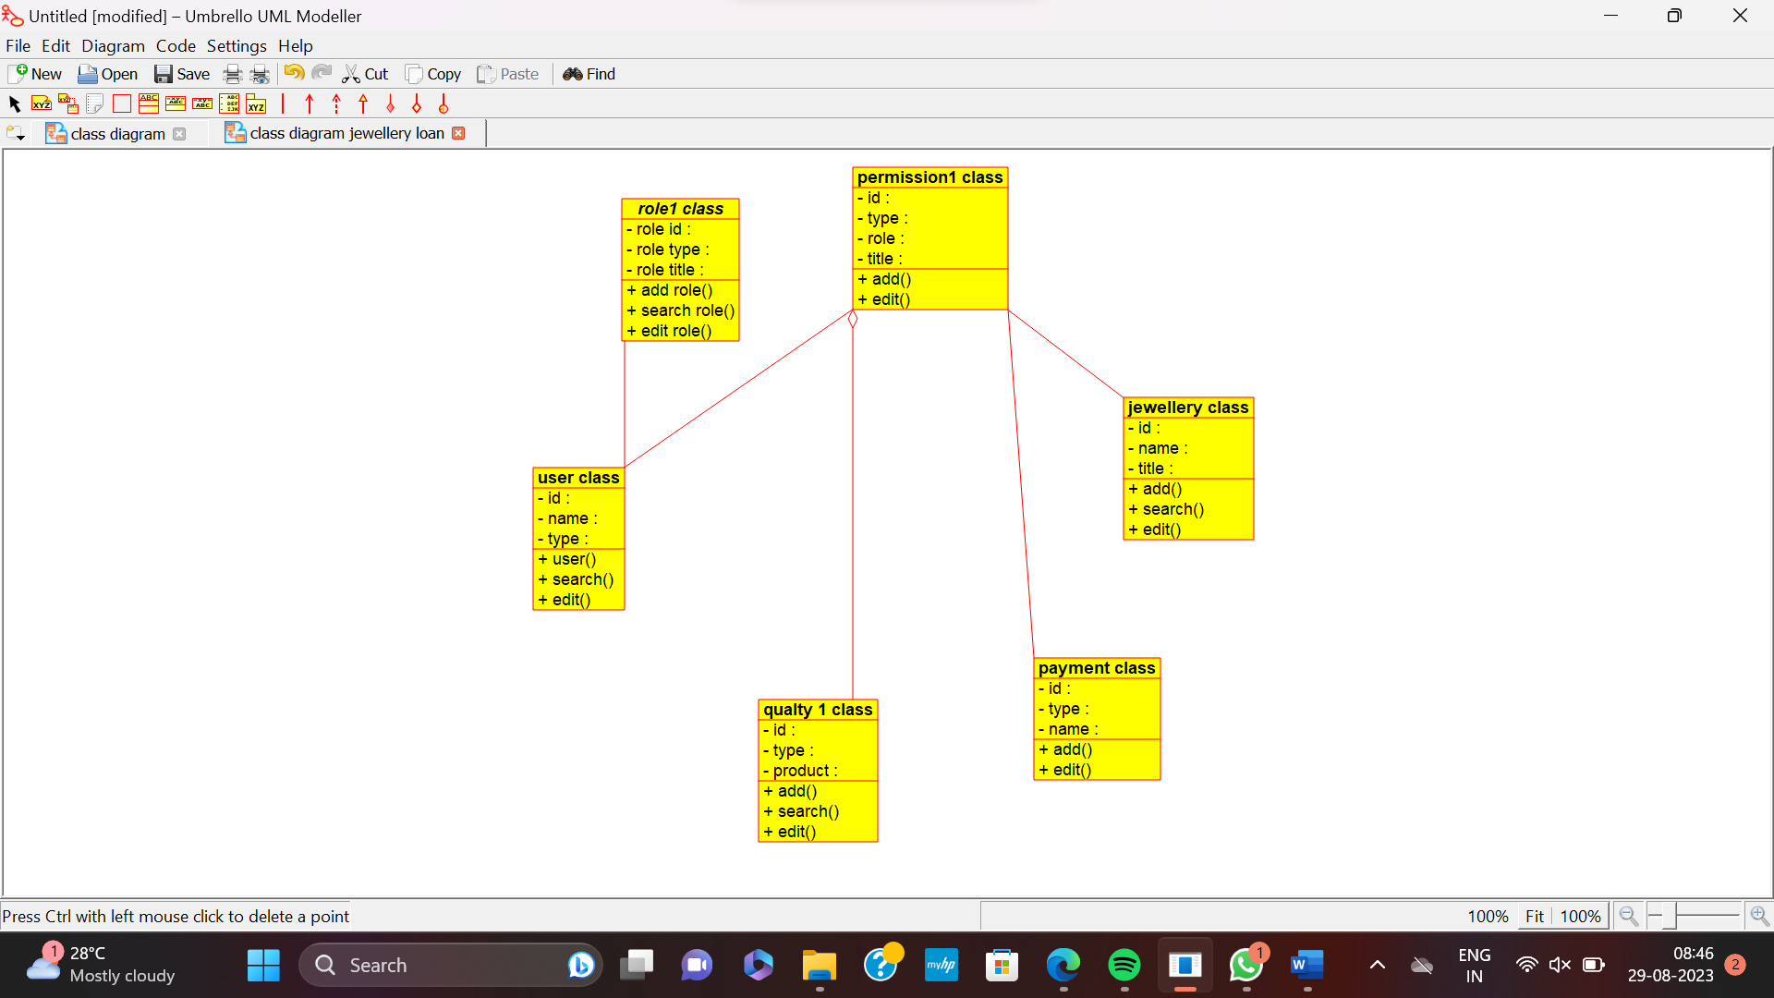

**USE CASE :**

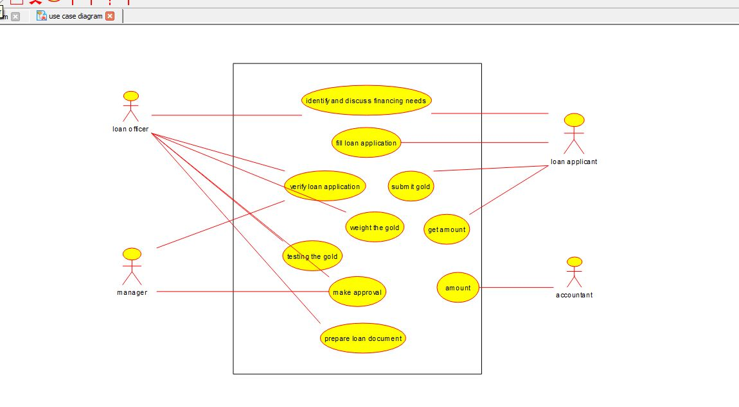

**SEQUENCE :**

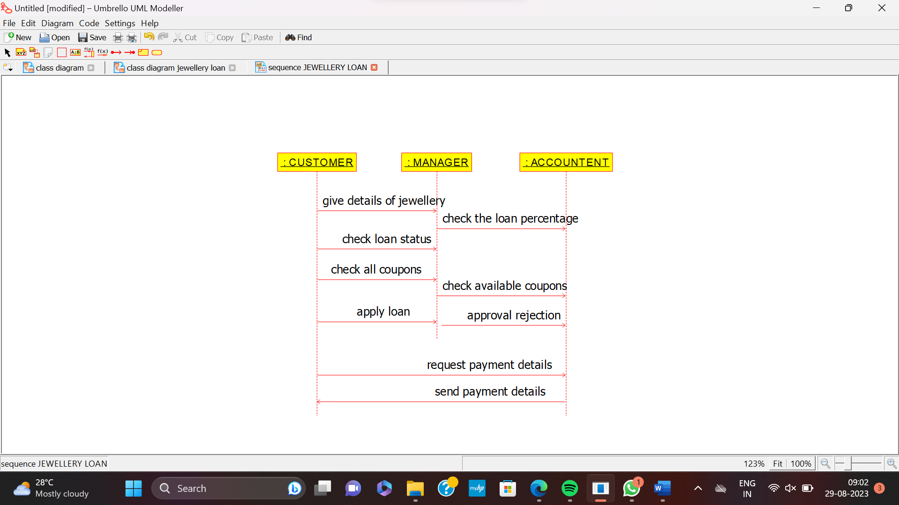

**RESULT** : Program was Executed Successfully using Umbrello**.**

**EXP 33:PERSONAL LOAN MANAGEMENT SYSTEM**

**AIM:** To draw the uml diagram for personal loan management system using umbrello.

**CLASS DIAGRAM**

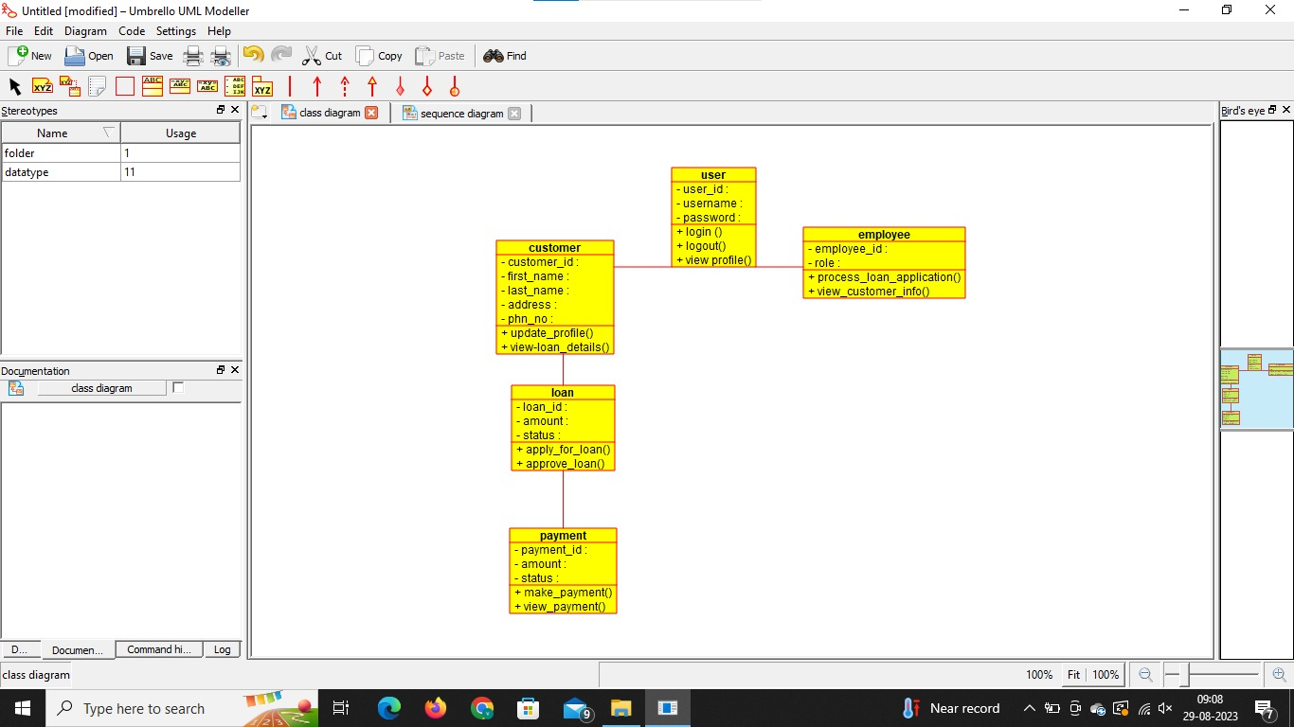

**USECASE**

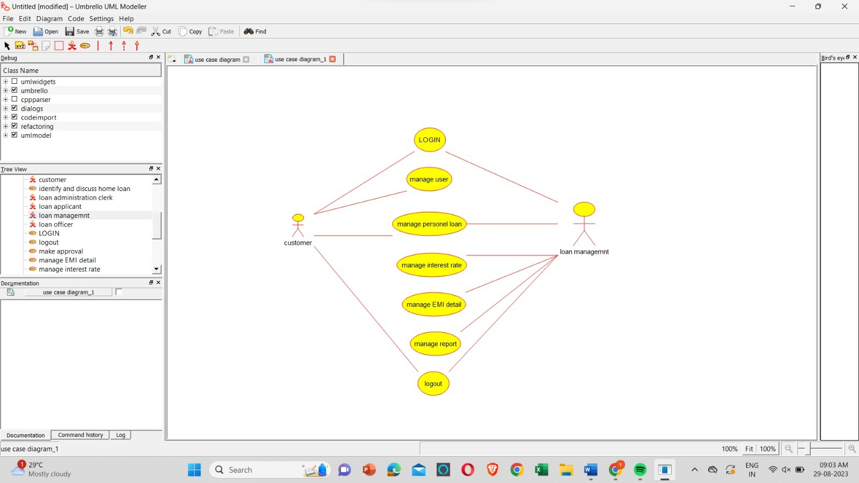

**SEQUENCE**

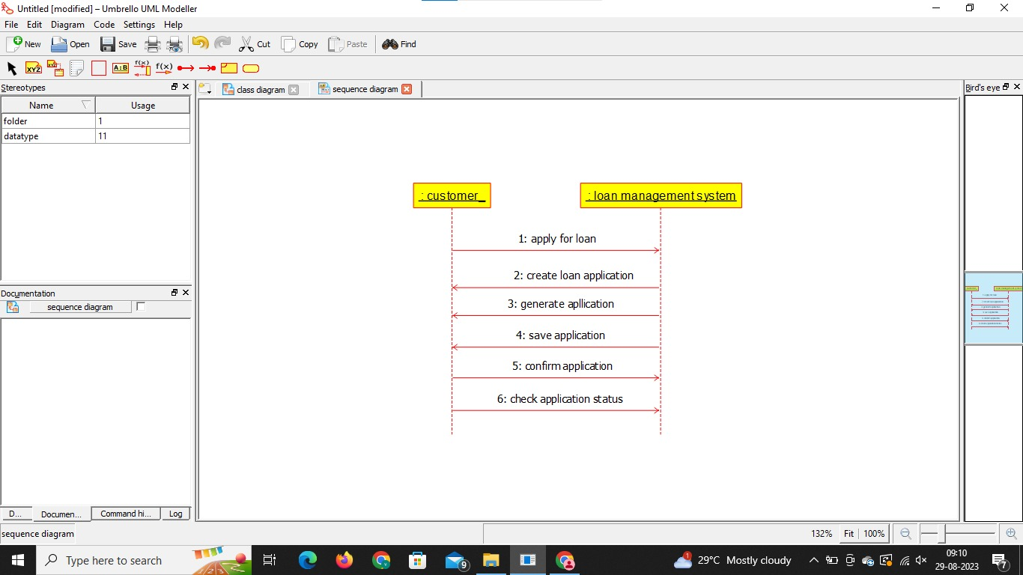

**RESULT** : Program was Executed Successfully using Umbrello**.**

**EXP 34:HOME LOAN MANAGEMENT SYSTEM**

**AIM: :** To draw the uml diagram for home loan management system using umbrello.

**USE CASE**

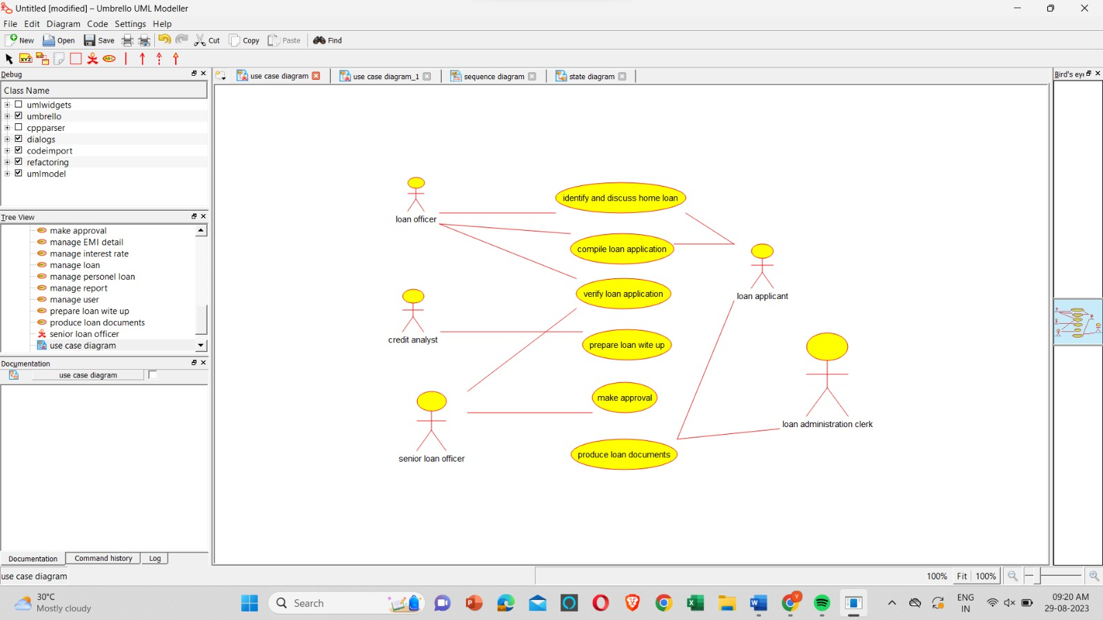

**SEQUENCE**

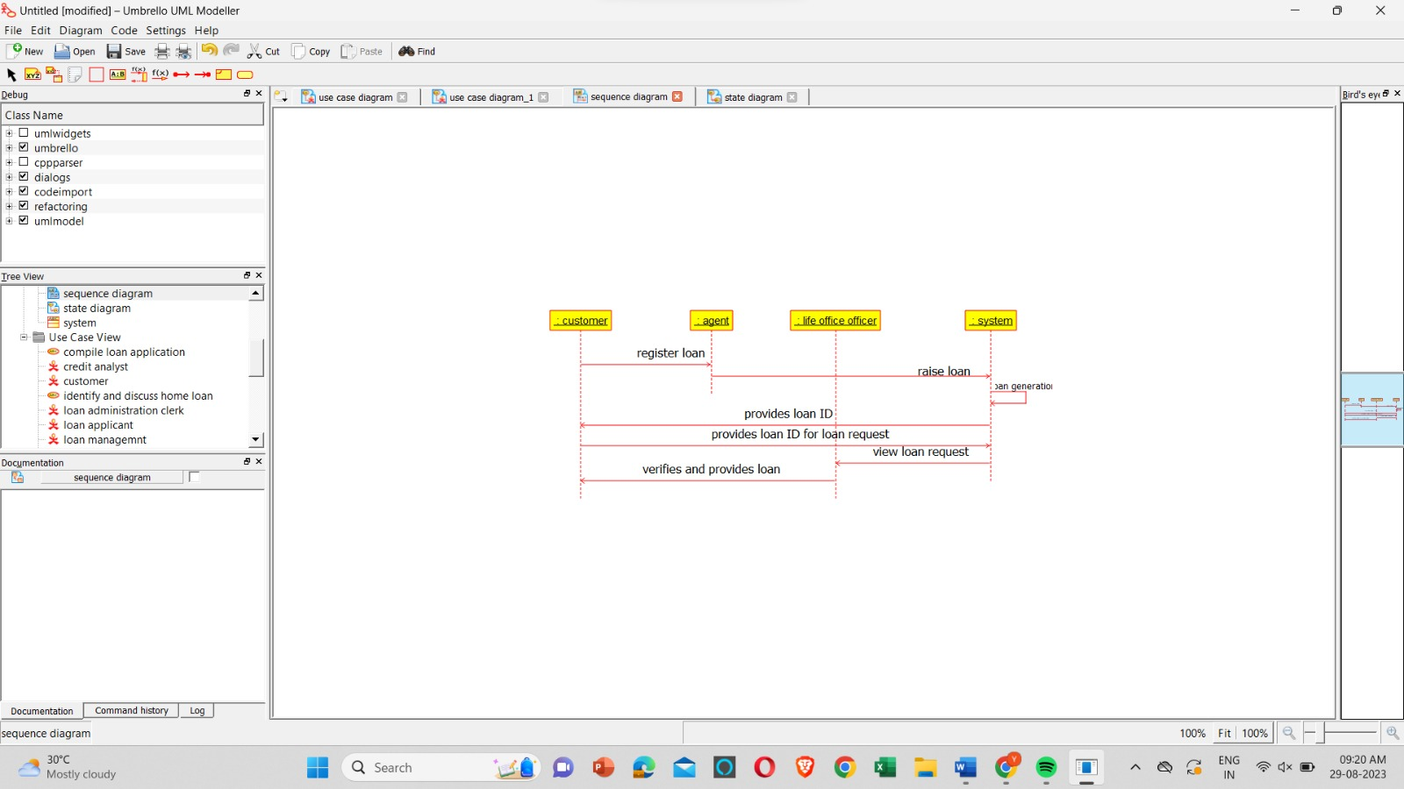

**ACTIVITY**

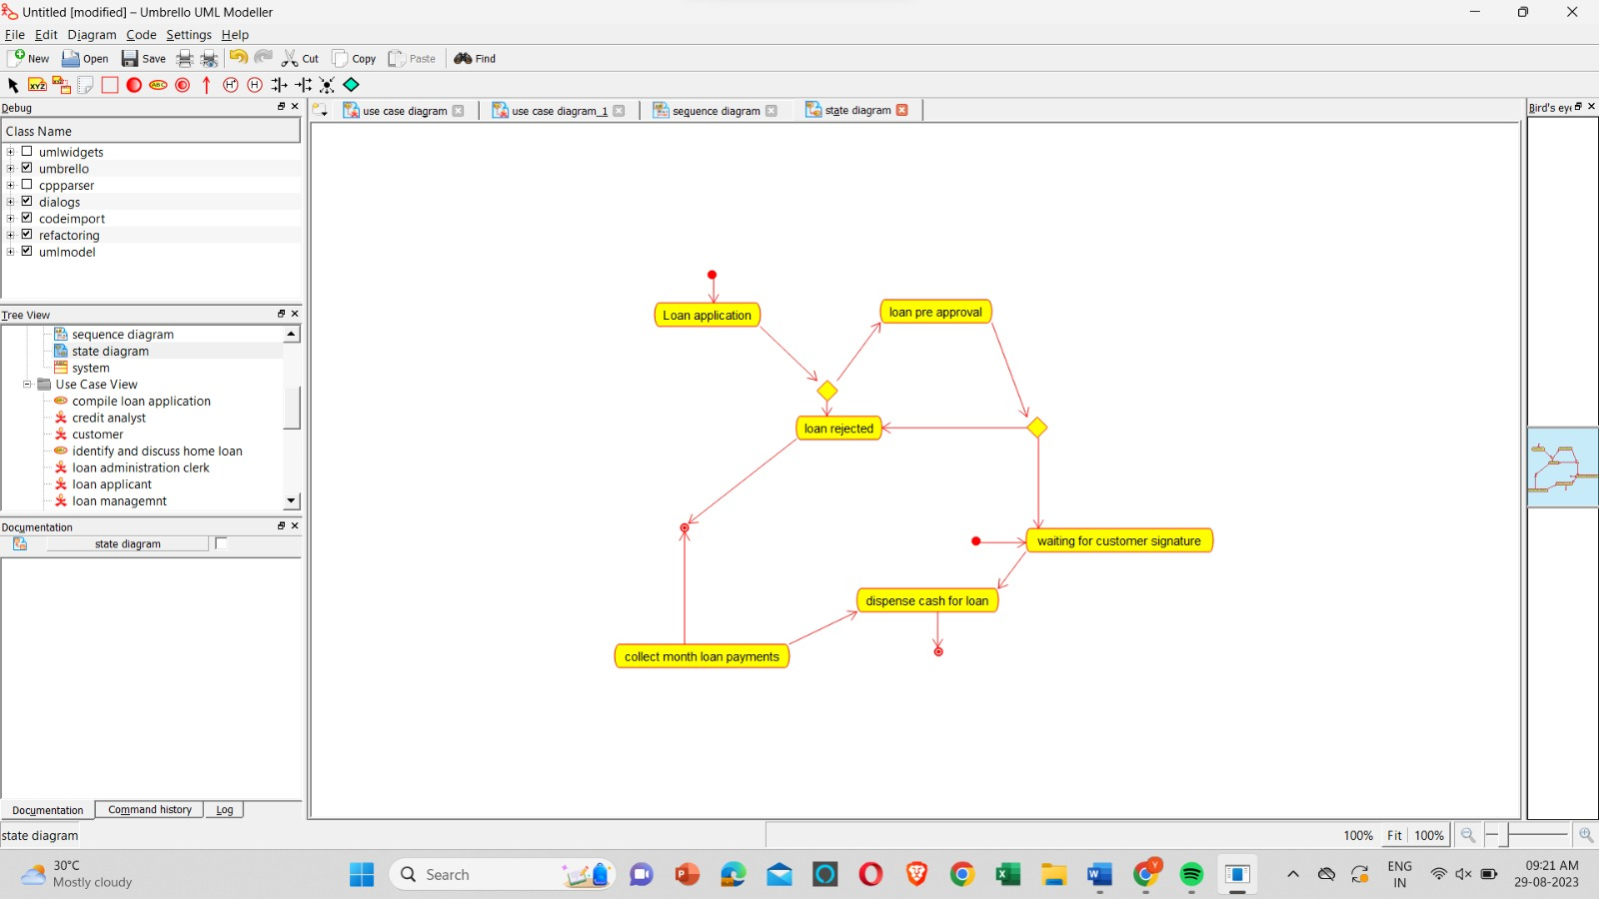

**RESULT** : Program was Executed Successfully using Umbrello.

**EXP 35: LAND REGISTRATION SYSTEM**

**AIM:** To draw the uml diagram for home loan management system using umbrello.

**SEQUENCE:**

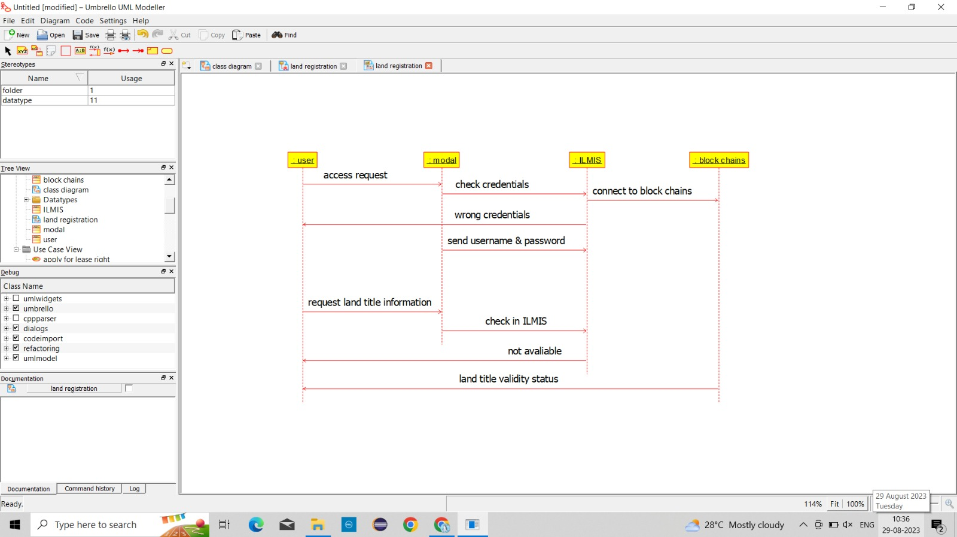

**USE CASE:**

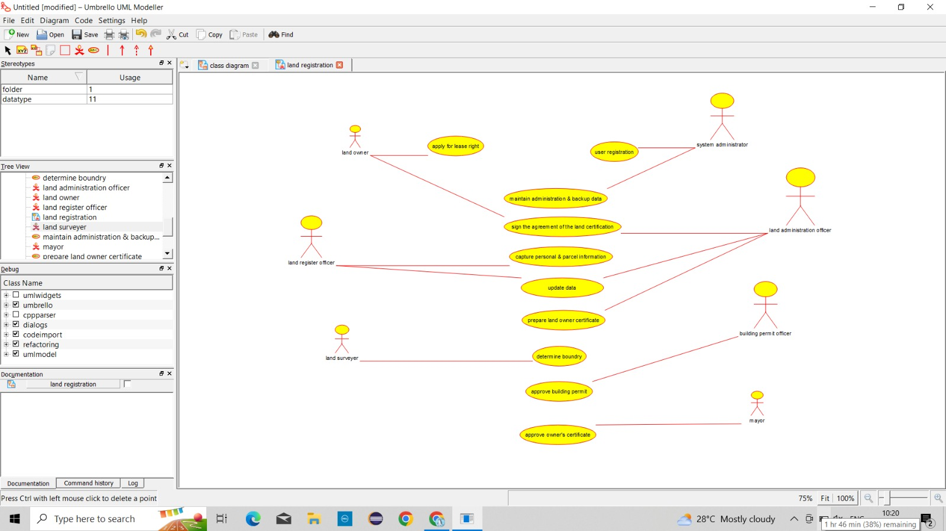

**ACTIVITY:**

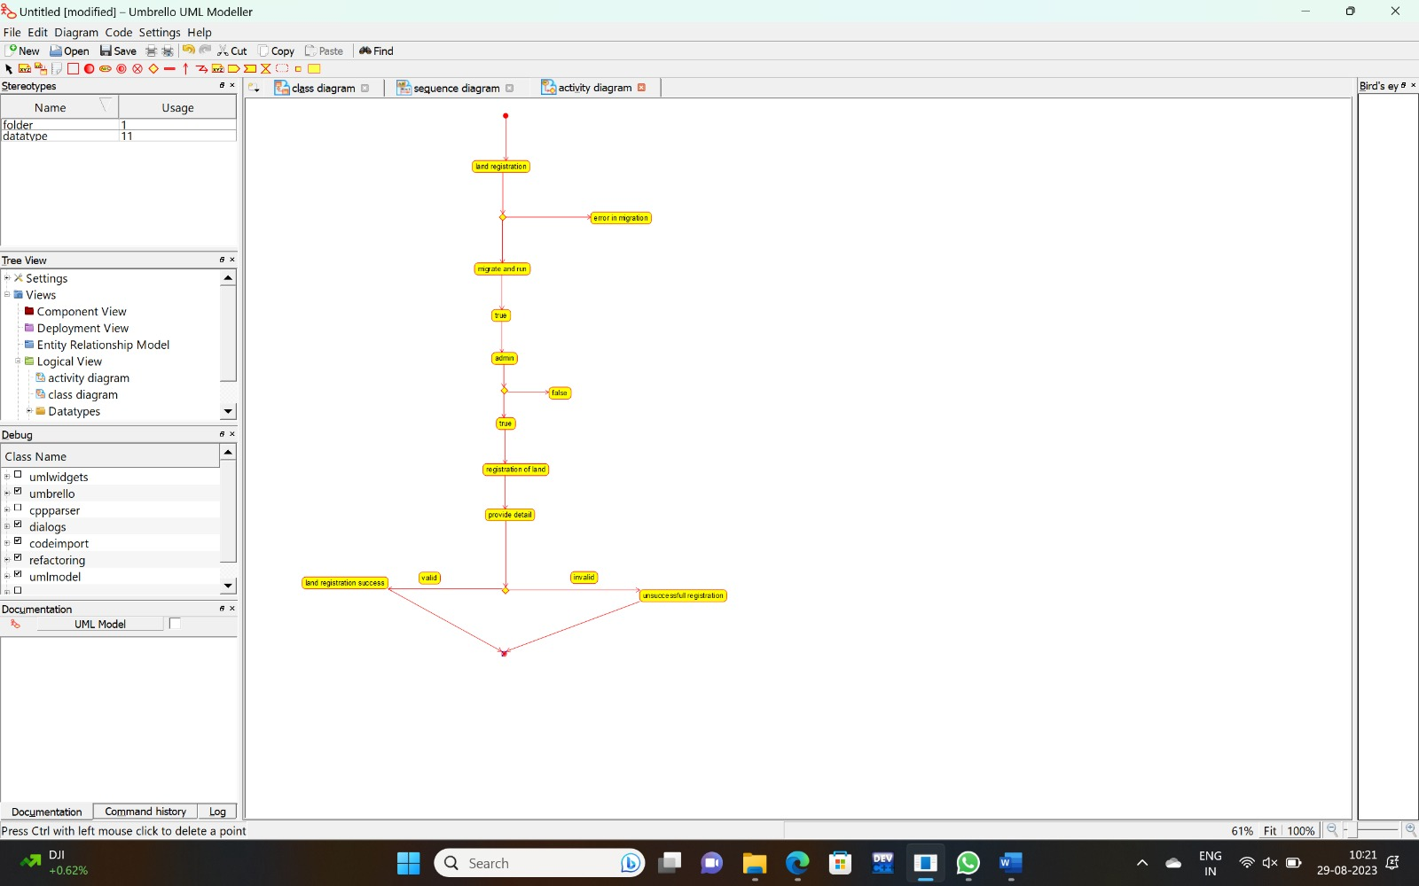

**RESULT** : Program was Executed Successfully using Umbrello.

**EXP 36: VEHICLE BOOKING SYSTEM**

**AIM:** To draw the uml diagram for vehicle booking system using umbrello.

**COMPONENT:**

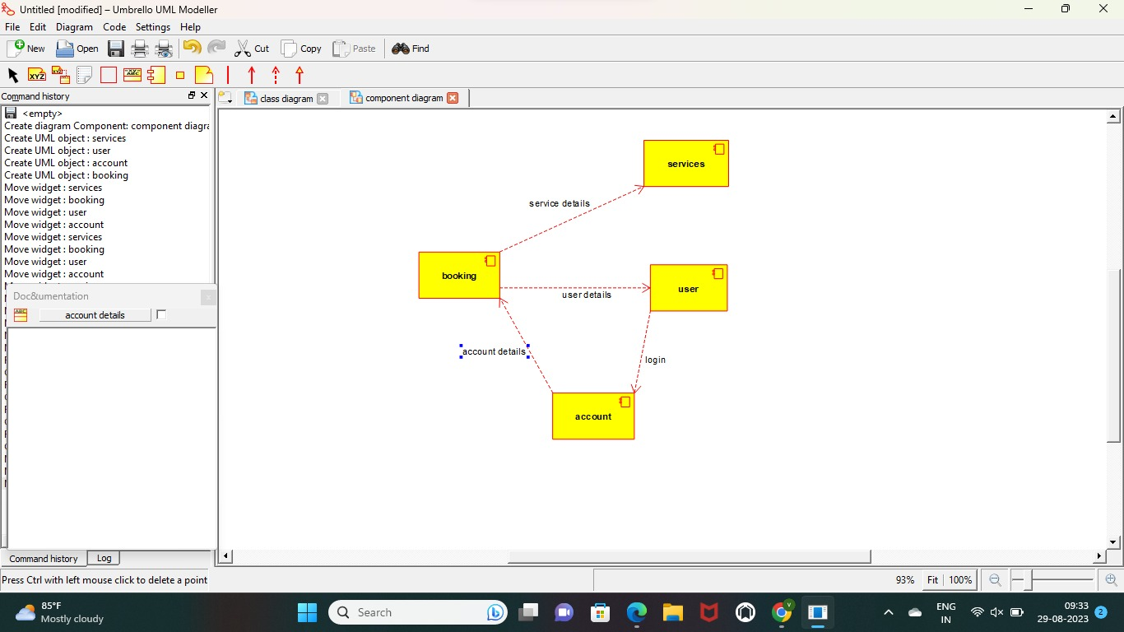

**USECASE**

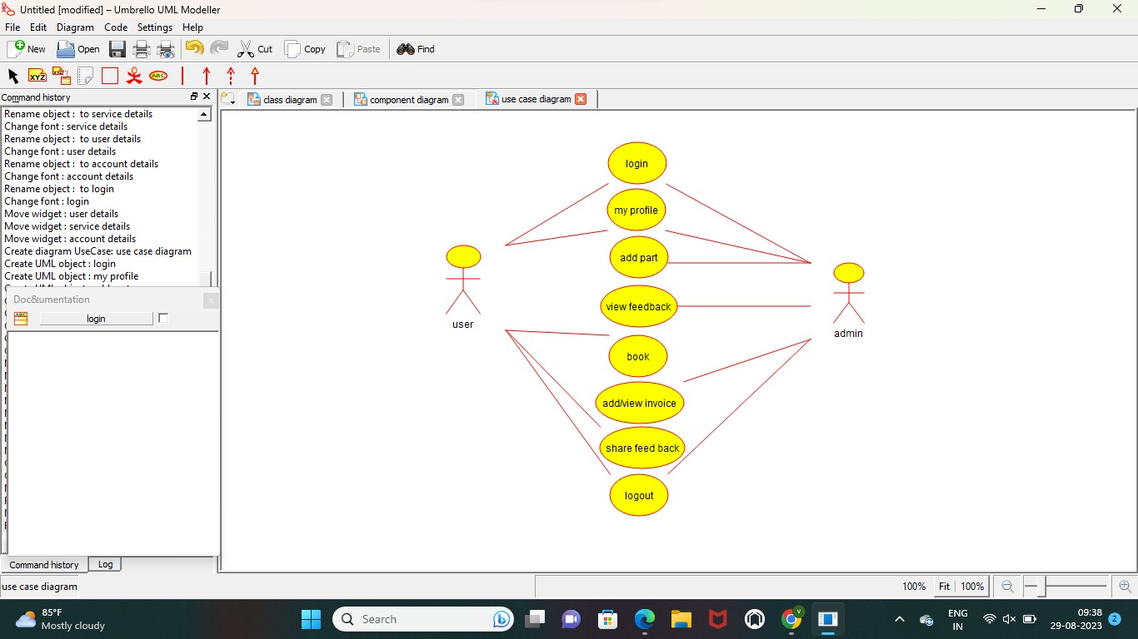

**SEQUENCE**

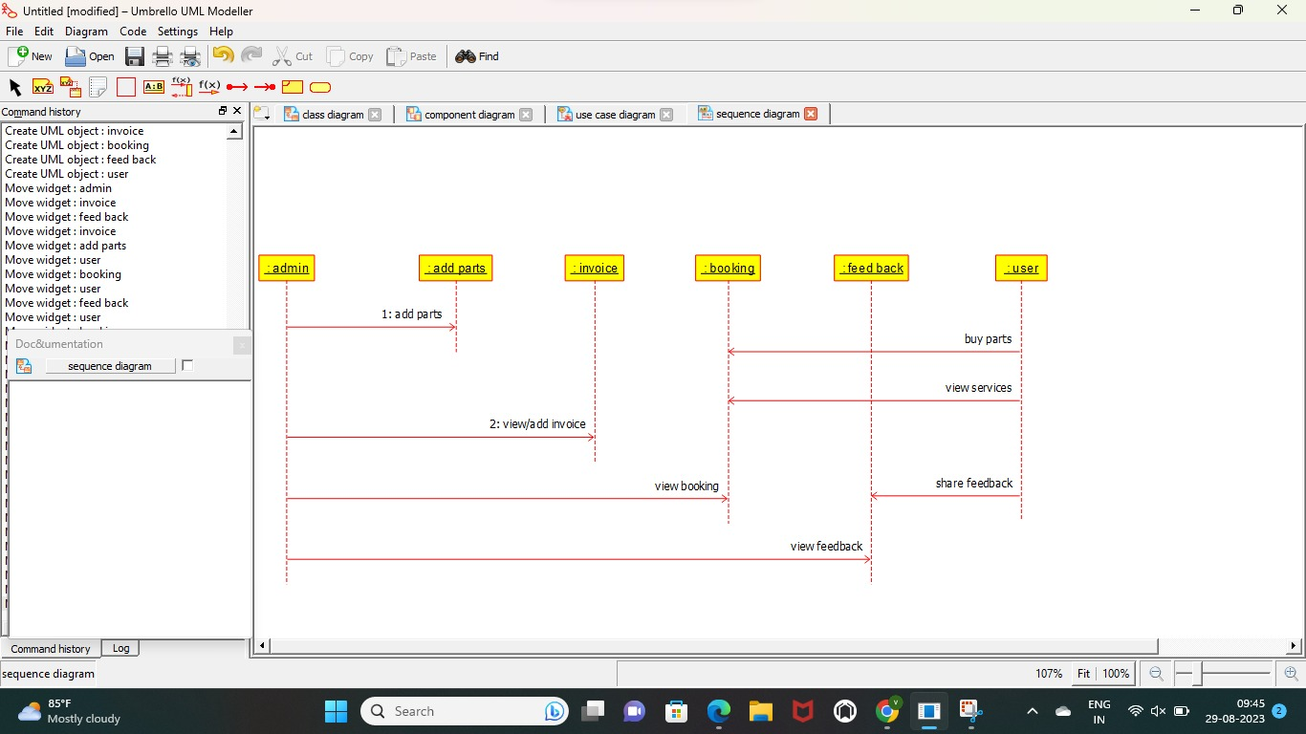

**RESULT** : Program was Executed Successfully using Umbrello.

**EXP 37:DOCTOR APPOINTMENT SYSTEM**

**AIM:** To draw the uml diagram for doctor appointment system using umbrello.

**SEQUENCE:**

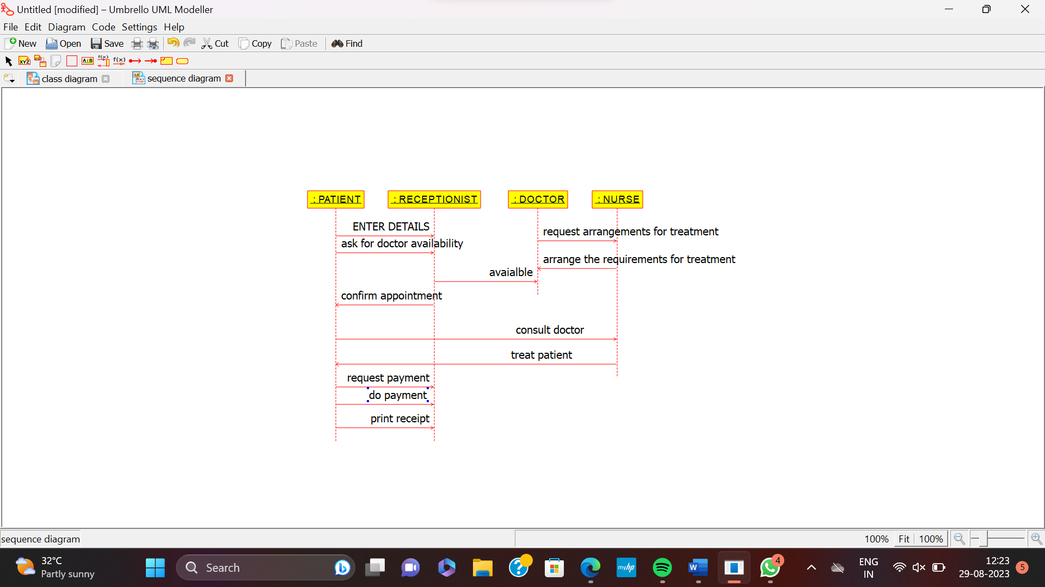

**USE CASE:**

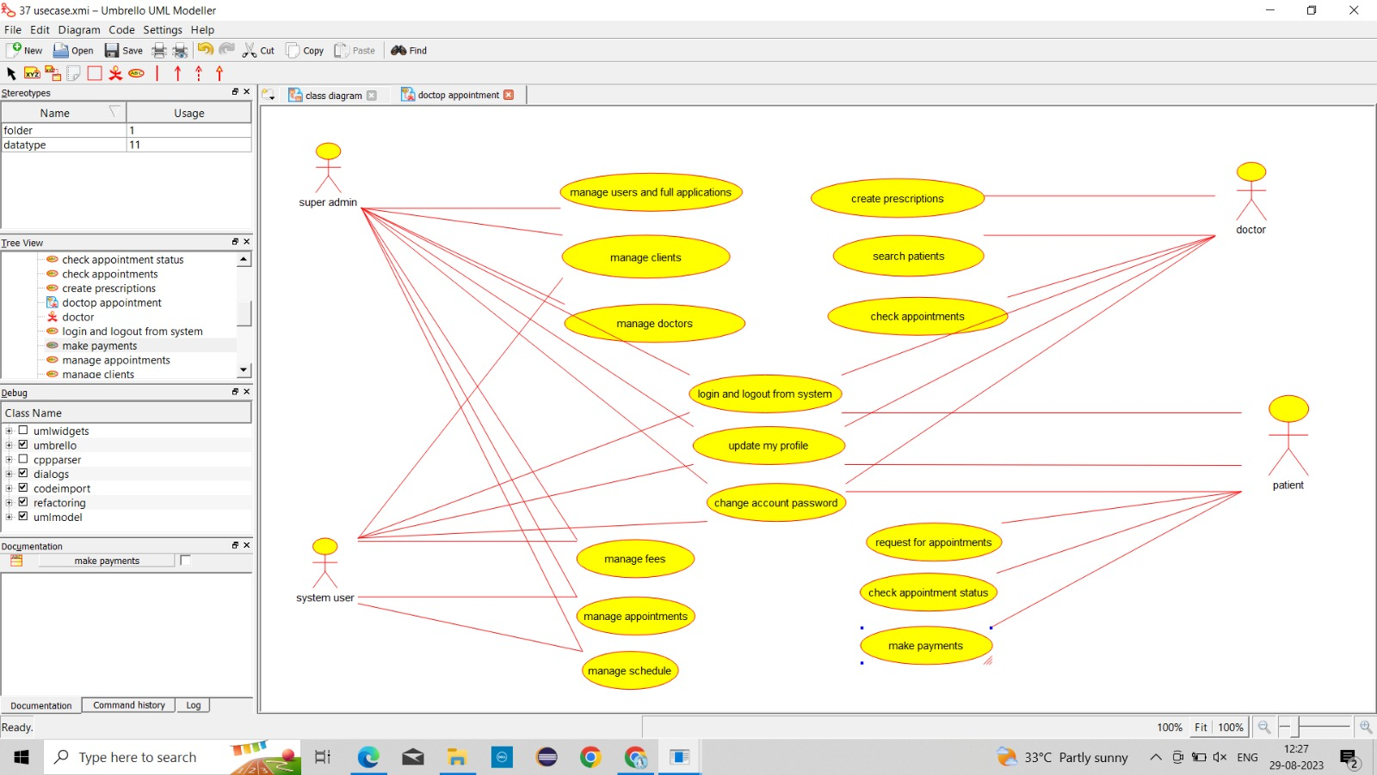

**ACTIVITY:**

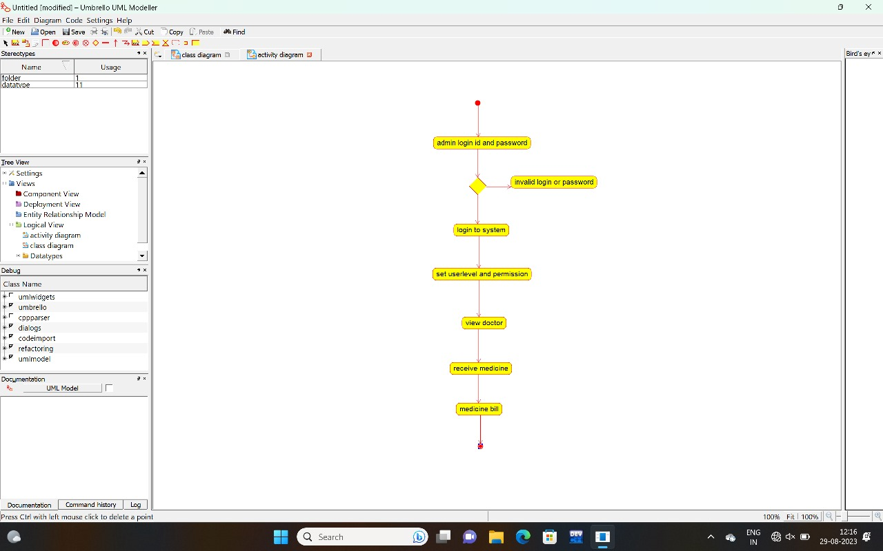

**RESULT** : Program was Executed Successfully using Umbrello.

**Exp 38:BEAUTY PARLOUR RESERVATION SYSTEM**

**AIM:** To draw the uml diagram for beauty parlour reservation system using umbrello.

**ACTIVITY:**

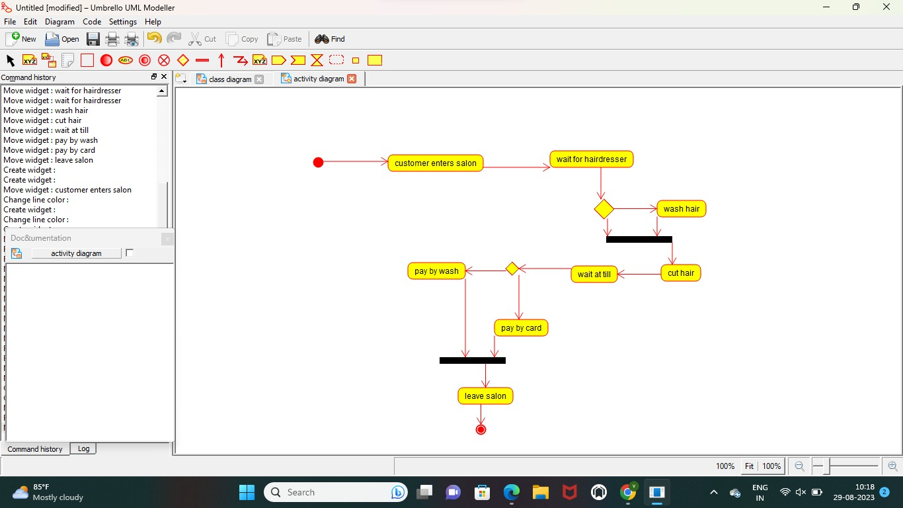

**SEQUENCE:**

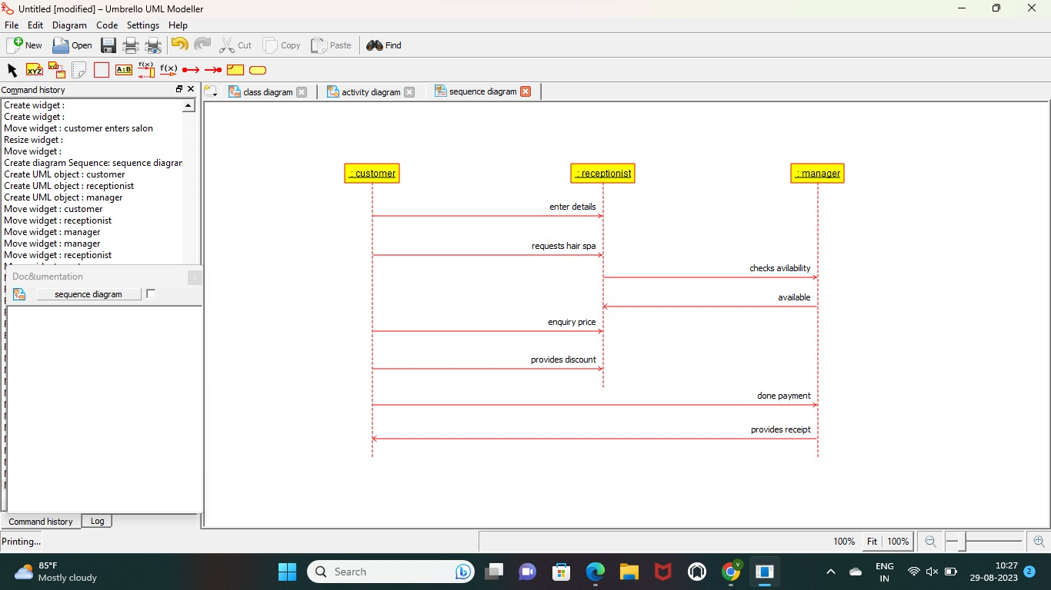

**CLASS**

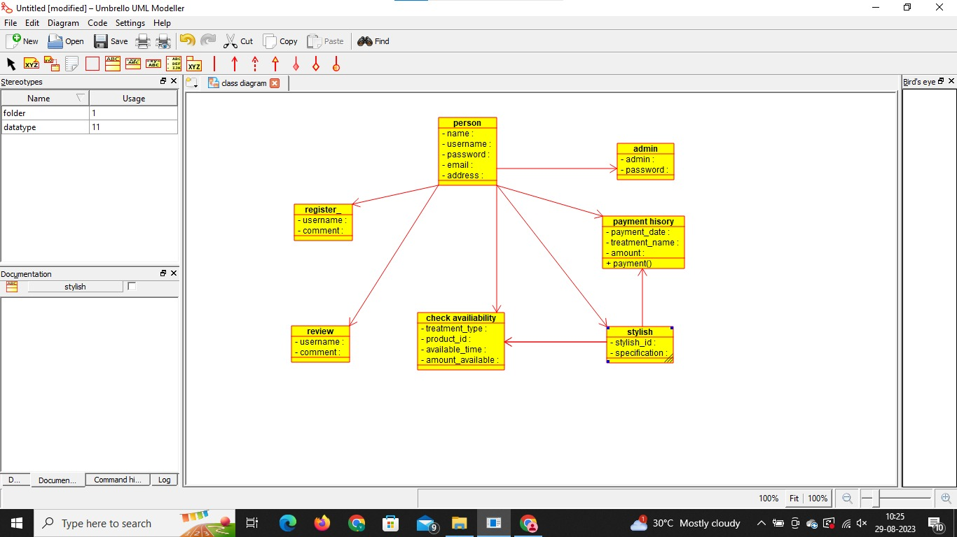

**RESULT** : Program was Executed Successfully using Umbrello.

**Exp 39:GARDENER BOOKING SYSTEM**

**AIM:** To draw the uml diagram for beauty gardener booking system using umbrello.

**COMPONENT:**

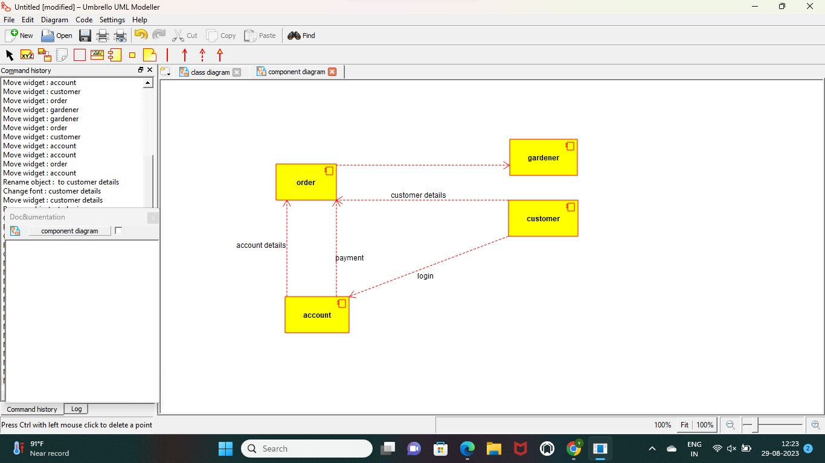

**USE CASE:**

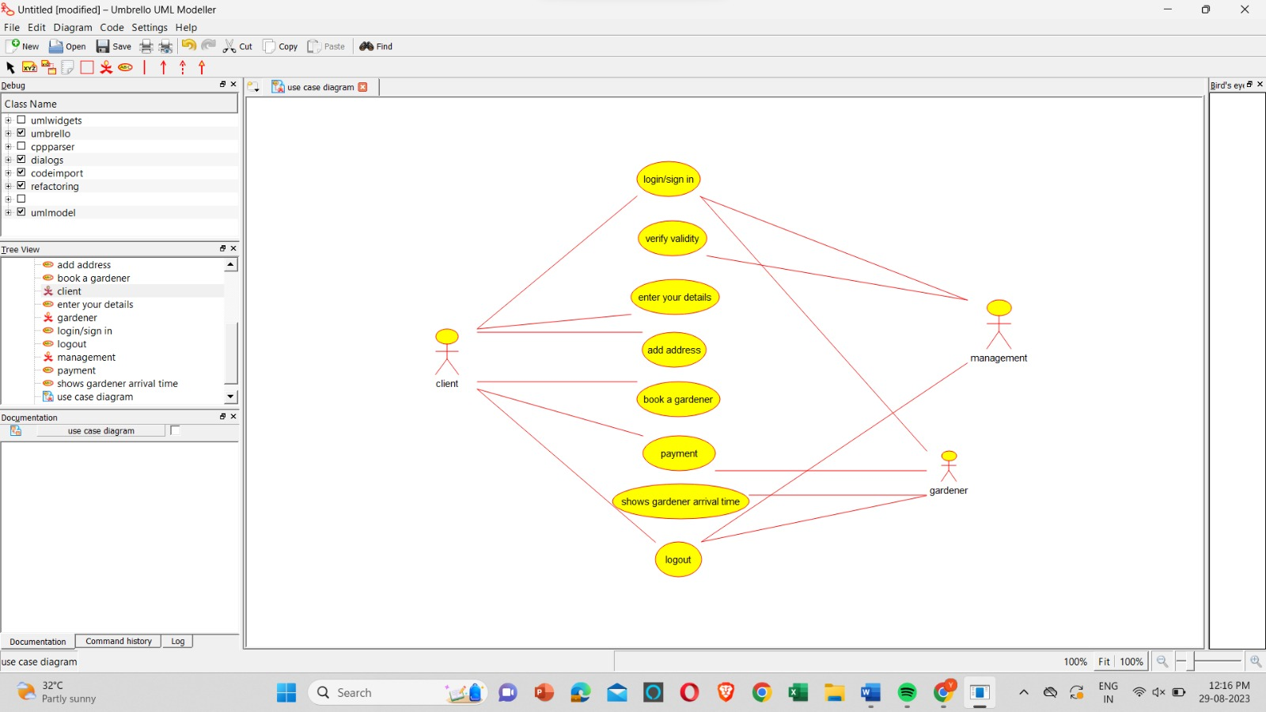

ACTIVITY:

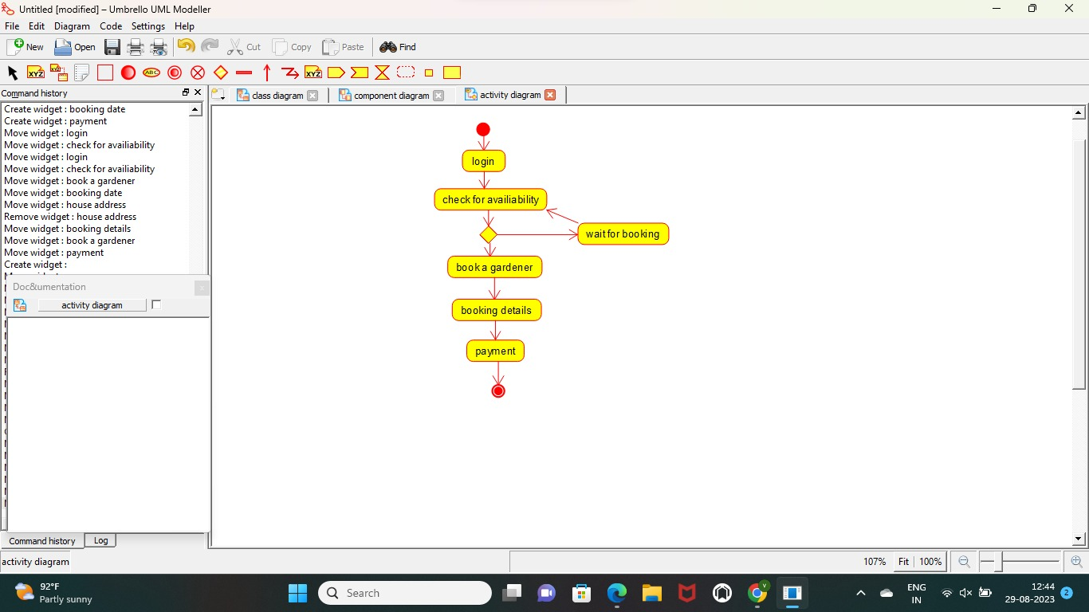

**RESULT** : Program was Executed Successfully using Umbrello.

**Exp 40:HOME TAX COLLECTION SYSTEM**

**AIM:** To draw the uml diagram for home tax collection system using umbrello.

**USECASE:**

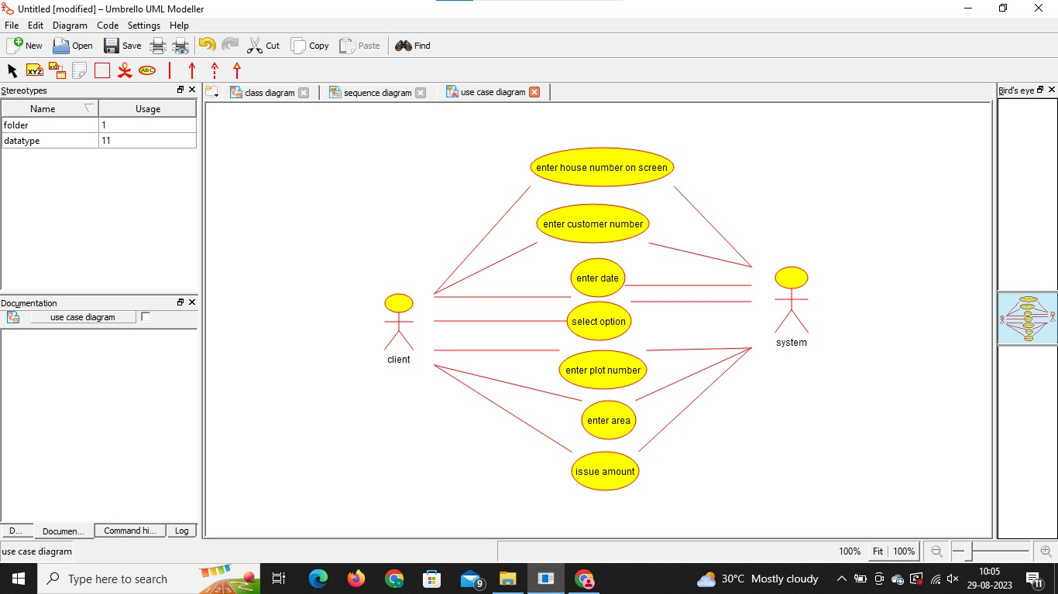

**SEQUENCE:**

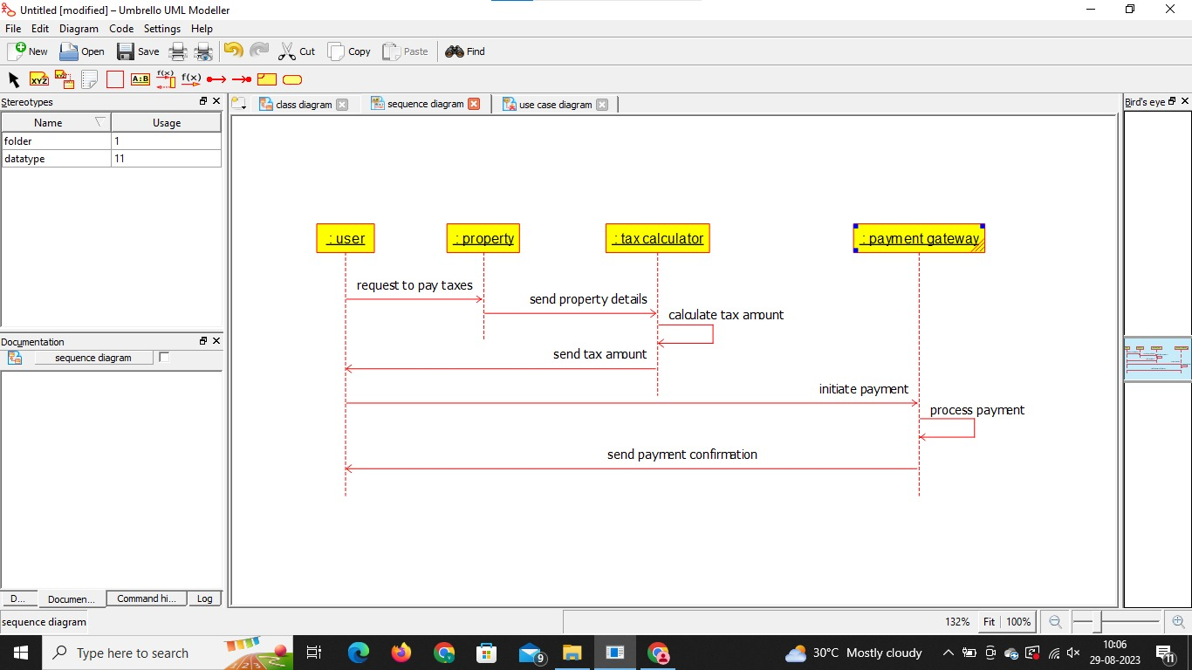

**CLASS:**

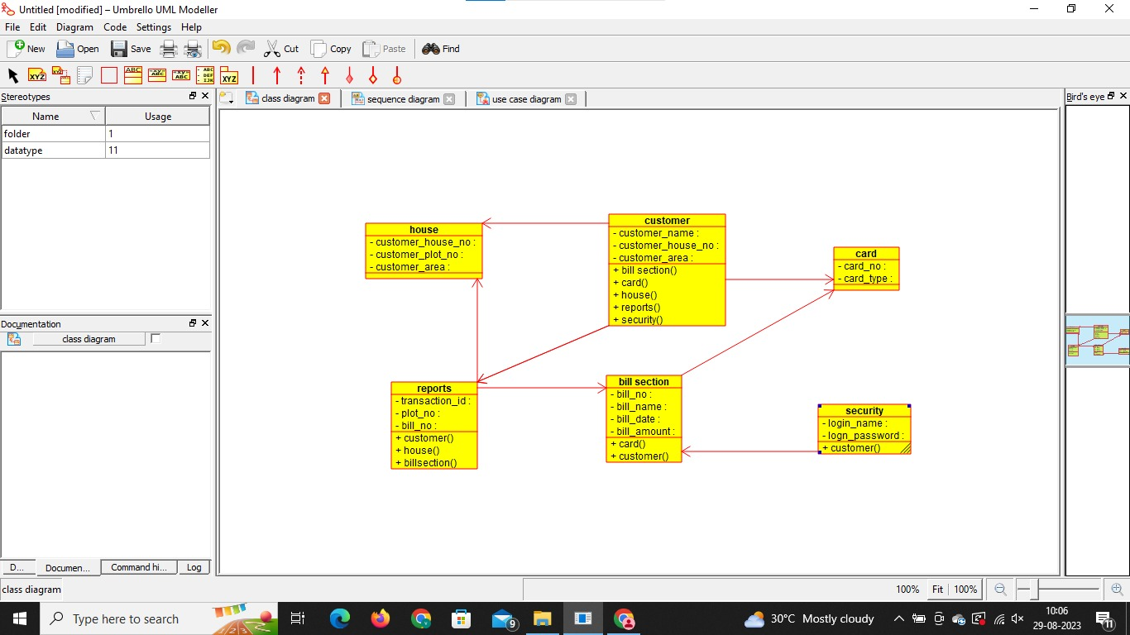

**RESULT** : Program was Executed Successfully using Umbrello.